
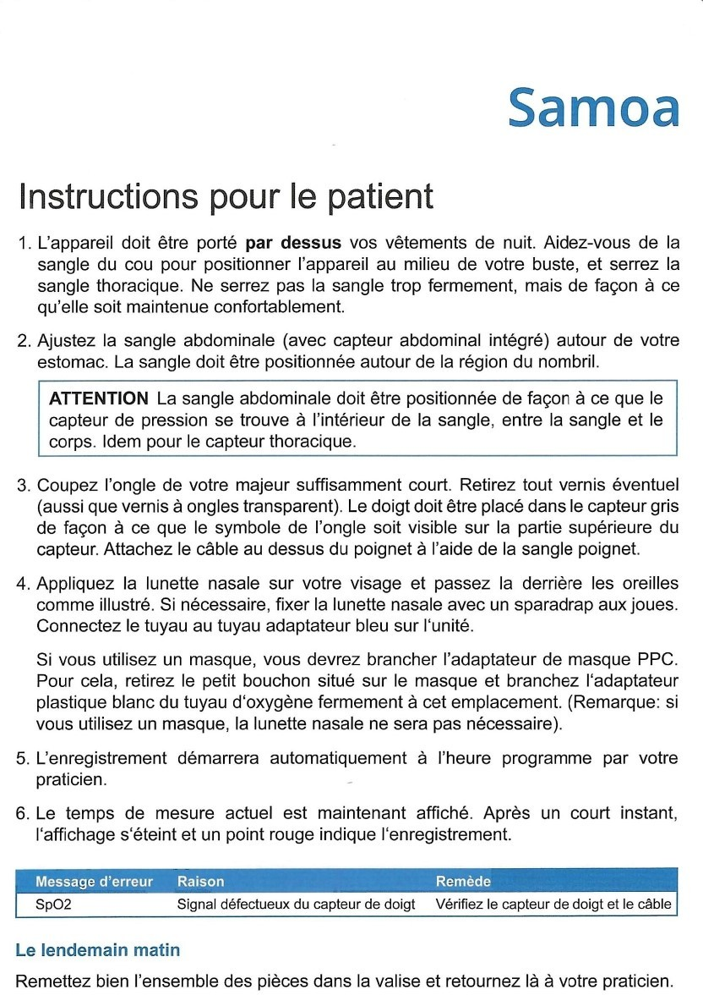

C A B I N E T D E C A R D I O L O G I E E T R Y T H M O L O G I E C A R D I O C H E C K - U P
Dr Sana AMRAOUI
Cardiologue-Rythmologue

